Lesson 9-3: Additional Control Structures

Exercise 1:

// Program Looping uses a count-controlled loop to read and
// sum 10 integer values and an event-controlled loop to
// read and sum values until a negative value is found.
// The data is on file Looping.dat.

#include <iostream>
#include <fstream>
using namespace std;

int main ()
{
ifstream inData;
int value;
int counter;
int sum;
inData.open("Looping.dat");

counter = 1;
sum = 0;
while (counter <= 10)
{// ten values read and summed
inData >> value;
sum = sum + value;
counter++;
}
cout << "The first sum is " << sum << endl;

inData >> value;
sum = 0;
while (value >= 0)
{// values are read and summed until a negative is read
sum = sum + value;
inData >> value;
}
cout << "The second sum is " << sum << endl;
system("PAUSE");
return 0;
}
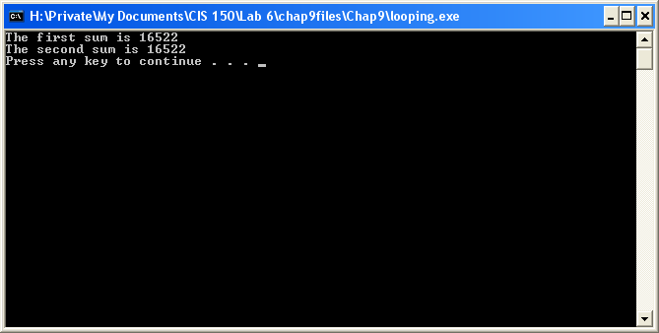

Exercise 2:

// Program Looping uses a count-controlled loop to read and
// sum 10 integer values and an event-controlled loop to
// read and sum values until a negative value is found.
// The data is on file Looping.dat.

#include <iostream>
#include <fstream>
using namespace std;

int main ()
{
ifstream inData;
int value;
int counter;
int sum;
inData.open("Looping.dat");

counter = 1;
sum = 0;

do
{
inData >> value;
sum = sum+ value;
counter++;
} while (counter <=10);

cout << "The first sum is " << sum << endl;

inData >> value;
sum = 0;
do
{
sum = sum + value;
inData >> value;
} while(value >=0);

cout << "The second sum is " << sum << endl;

system("PAUSE");
return 0;
}
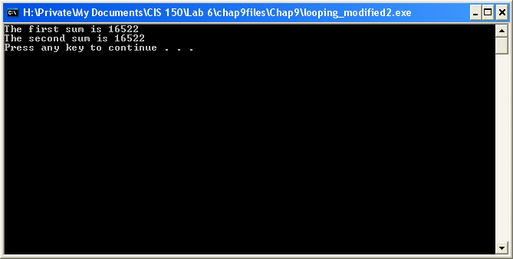

Exercise 3:

Yes, the program Looping can be rewritten using a for statement for each loop. The for statement is recommended for count-controlled loops and the program Looping contains one.

// Program Looping uses a count-controlled loop to read and
// sum 10 integer values and an event-controlled loop to
// read and sum values until a negative value is found.
// The data is on file Looping.dat.

#include <iostream>
#include <fstream>
using namespace std;

int main ()
{
ifstream inData;
int value;
int counter;
int sum;
inData.open("Looping.dat");

counter = 1;
sum = 0;

for (counter = 1; counter <=10; counter++)
{
inData >> value;
sum = sum + value;
}

cout << "The first sum is " << sum << endl;

inData >> value;
sum = 0;
do
{
sum = sum + value;
inData >> value;
} while(value >=0);

cout << "The second sum is " << sum << endl;

system("PAUSE");
return 0;
}
